Lecture 3. DNA Extraction and Quantitation of Forensic Samples
DNA EXTRACTION
A biological sample obtained from a crime scene in the form of a blood or semen stain or a tissue (blood or buccal swab) sample from a known individual contains a number of substances besides DNA. DNA molecules must be separated from other cellular material before they can be examined. Cellular proteins that package and protect DNA in the environment of the cell can inhibit the ability to analyze the DNA. Therefore, DNA extraction methods have been developed to separate proteins and other cellular materials from the DNA molecules. The quantity and quality of DNA often need to be measured prior to proceeding further with analytical procedures to ensure optimal results. This chapter will focus on the DNA extraction process while the following chapter will cover assessment of DNA quantity and quality prior to further sample processing. Several primary techniques for DNA extraction are used in today’s forensic DNA laboratory: organic extraction, Chelex extraction, and FTA or solid-phase extraction ( Figure 5.1 ). The exact extraction or DNA isolation procedure varies depending on the type of biological evidence being examined. For example, whole blood must be treated differently from a bloodstain or a bone fragment. Organic extraction, sometimes referred to as phenol-chloroform extraction, has been in use for the longest period of time and may be used for situations where either RFLP or PCR typing is performed. High-molecular-weight DNA, which was essential for early RFLP methods, may be obtained most effectively with organic extraction. The Chelex method of DNA extraction is more rapid than the organic extraction method. In addition, Chelex extraction involves fewer steps and thus fewer opportunities for sample-to-sample contamination. However, it produces single-stranded DNA as a result of the extraction process and therefore is only useful for PCR-based testing procedures.
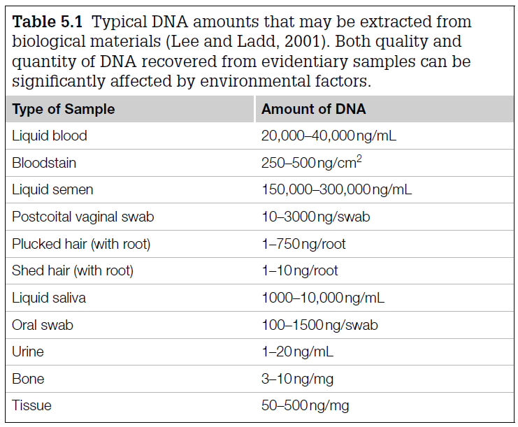
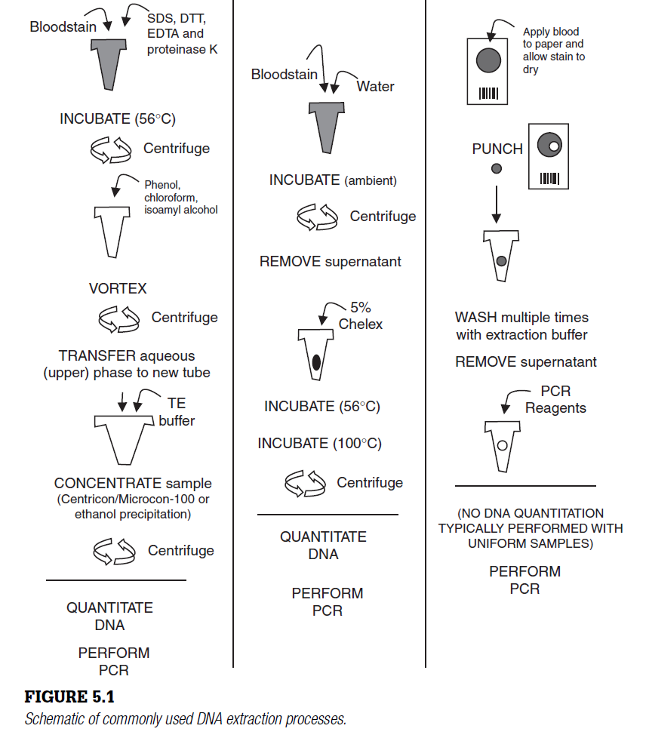 All samples must be carefully handled regardless of the DNA extraction method to avoid sample-to-sample contamination or introduction of extraneous DNA. The extraction process is probably where the DNA sample is more susceptible to contamination in the laboratory than at any other time in the forensic DNA analysis process. For this reason, laboratories usually process the evidence samples at separate times and sometimes even different locations from the reference samples. For many years, a popular method for preparation of reference samples was to make a bloodstain by applying a drop of blood on to a cotton cloth, referred to as a swatch, to produce a spot about 1 cm 2 in area. Ten microliters of whole blood, about the size of a drop, contains approximately 70,000 to 80,000 white blood cells and should yield approximately 500 ng of genomic DNA. The actual yield will vary with the number of white blood cells present in the sample and the effi ciency of the DNA extraction process. The typical amounts of DNA extracted from various biological materials is shown in Table 5.1 .
Extracted DNA is typically stored at _ 20 ° C, or even _ 80 ° C for long-term storage, to prevent nuclease activity. Nucleases are protein enzymes found in cells that degrade DNA to allow for recycling of the nucleotide components. Nucleases need magnesium to work properly so one of the measures to prevent them from digesting DNA in blood is the use of purple-topped tubes containing a blood preservative known as EDTA. The EDTA chelates, or binds up, most of the free magnesium and thus helps prevent the nucleases from destroying the DNA in the collected blood sample.
Organic (phenol-chloroform) extraction
Organic extraction was for many years the most widely used method for DNA extraction. In the past decade, new extraction methods have been developed that use chemicals which are far less toxic than phenol. Organic extraction involves the serial addition of several chemicals. First sodium dodecylsulfate (SDS) and proteinase K are added to break open the cell walls and to break down the proteins that protect the DNA molecules while they are in chromosomes. Next a phenol-chloroform mixture is added to separate the proteins from the DNA. The DNA is more soluble in the aqueous portion of the organic – aqueous mixture. When centrifuged, the unwanted proteins and cellular debris are separated away from the aqueous phase and double-stranded DNA molecules can be cleanly transferred for analysis. Some initial protocols involved a Centricon 100 (Millipore, Billerica, MA) dialysis and concentration step in place of the ethanol precipitation to remove heme inhibitors. While the organic extraction method works well for recovery of highmolecular weight DNA, it is time consuming, involves the use of hazardous chemicals, and requires the sample to be transferred between multiple tubes (which increases the risk of error or contamination).
Chelex extraction
An alternative and inexpensive procedure for DNA extraction that has become popular among forensic scientists is the use of a chelating-resin suspension that can be added directly to the sample (e.g., blood, bloodstain, or semen). Introduced in 1991 to the forensic DNA community, Chelex 100 (Bio-Rad Laboratories, Hercules, CA) is an ion-exchange resin that is added as a suspension to the samples. Chelex is composed of styrene divinylbenzene copolymers containing paired iminodiacetate ions that act as chelating groups in binding polyvalent metal ions such as magnesium. Like iron fi lings to a magnet, the magnesium ions are drawn in and bound up. By removing the magnesium from the reaction, DNA-destroying nuclease enzymes are inactivated and the DNA molecules are thus protected. In most protocols, biological samples such as bloodstains are added to a 5% Chelex suspension and boiled for several minutes to break open the cells and release the DNA. An initial, prior wash step is helpful to remove possible contaminants and inhibitors such as heme and other proteins. The exposure to 100 ° C temperatures denatures the DNA as well as disrupt the cell membranes and destroy the cell proteins. After a quick spin in a centrifuge to pull the Chelex resin and cellular debris to the bottom of the tube, the supernatant is removed and can be added directly to the PCR amplifi cation reaction. Chelex extraction procedures for recovering DNA from bloodstains or semencontaining stains are not effective for RFLP typing because Chelex denatures double-stranded DNA and yields single-stranded DNA from the extraction process. Thus, it can only be followed by PCR-based analyses. However, Chelex extraction is an advantage for PCR-based typing methods because it removes inhibitors of PCR and uses only a single tube for the DNA extraction, which reduces the potential for laboratory-induced contamination.
The addition of too much whole blood or too large a bloodstain to the Chelex extraction solution can result in some PCR inhibition. The AmpFlSTR kit manuals recommend 3 μ L whole blood or a bloodstain approximately 3 mm _ 3 mm.
FTA ™ paper
Another approach to DNA extraction involves the use of FTA paper. In the late 1980s, FTA paper was developed by Lee Burgoyne at Flinders University in Australia as a method for storage of DNA. FTA originally stood for ‘ Fitzco/Flinder Technology Agreement. ’ FTA paper is an absorbent cellulose-based paper that contains four chemical substances to protect DNA molecules from nuclease degradation and preserve the paper from bacterial growth. As a result, DNA on FTA paper is stable at room temperature over a period of several years. However, a 2002 study evaluating FTA and three other commercial papers as DNA storage media found little difference in their ability to obtain typeable STR results after 19 months of storage. Use of FTA paper simply involves adding a spot of blood to the paper and allowing the stain to dry. The cells are lysed upon contact with the paper, and DNA from the white blood cells is immobilized within the matrix of the paper. A small punch of the paper is removed from the FTA card bloodstain and placed into a tube for washing. The bound DNA can then be purifi ed by washing it with a solvent to remove heme and other inhibitors of the PCR reaction. This purifi cation of the paper punch can be seen visually because as the paper is washed, the red color is removed with the supernatant. The cleanpunch is then added directly to the PCR reaction. Alternatively, some groups have performed a Chelex extraction on the FTA paper punch and used the supernatant in the PCR reaction. A major advantage of FTA paper is that consistent results may be obtained without quantifi cation. Furthermore, the procedure may be automated on a robotic workstation. For situations where multiple assays need to be run on the same sample, a bloodstained punch may be reused for sequential DNA amplifi cations and typing. Unfortunately, dry paper punches do not like to stay in their assigned tubes and due to static electricity can ‘ jump ’ between wells in a sample tray. Thus, this method is not as widely used today as was once envisioned. However, due to its preservation and storage capabilities, efforts have been made to use FTA cards for more widespread collection of crime scene evidence.
SOLID-PHASE DNA EXTRACTION METHODS
With the desire to automate more steps in DNA analysis, many laboratorieshave moved to various forms of solid-phase extraction where DNA is selectively bound to a substrate such as silica particles and then released following stringent washes that purify the bound DNA molecules away from proteins and other cellular components. The most widely used solid-phase extraction methods are Qiagen columns, DNA IQ, and PrepFiler.
Qiagen extraction chemistry and kits
Solid -phase extraction methods for DNA have been developed in recent years informats that enable high-throughput DNA extractions. One of the most active efforts in this area is with silica-based extraction methods and products from Qiagen, Inc. (Valencia, CA). For more than a decade, QIAamp spin columns have proven effective as a means of DNA isolation. In this approach, nucleic acids selectively absorb to a silica support, such as small glass beads, in the presence of high concentrations of chaotropic salts such as guanidine hydrochloride, guanidine isothiocyanate, sodium iodide, and sodium perchlorate. These chaotropic salts disrupt hydrogen-bonding networks in liquid water and thereby make denatured proteins and nucleic acids more thermodynamically stable than their native folded or structured counterparts. If the solution is more acidic than pH 7.5, DNA adsorption to the silica is typically around 95% and unwanted impurities can be washed away. Under alkaline conditions and low salt concentrations, the DNA will effi ciently elute from the silica material. This solid-phase extraction approach can be performed with centrifugation or vacuum manifolds in single tube or 96-well plate formats and is even being developed into formats that will work on a microchip. Several robotic platforms have been developed to enable automated processing of Qiagen DNA extractions including the EZ1, M48, and QIAcube.
DNA IQ
Another solid-phase extraction approach is the DNA IQ ™ system marketed by Promega Corporation (Madison, WI). The DNA IQ system, which st ‘ isolation ’ and ‘ quantitation, ’ utilizes the same silica-based DNA binding and elution chemistries as Qiagen kits but with silica-coated paramagnetic resin. With this approach, DNA isolation can be performed in a single tube by simply adding and removing solutions. First , the DNA molecules are reversibly bound to the magnetic beads in solution with a solution pH more acidic than pH 7.5 (the same as noted previously for the Qiagen chemistry). A magnet is used to draw the silica-coated magnetic beads to the bottom or side of the tube leaving any impurities in solution. These solution impurities (proteins, cell debris, etc.) are easily removed by drawing the liquid off of the beads. The magnetic particles with DNA attached can be washed multiple times to more thoroughly clean the DNA. Finally, a defined amount of DNA can be released into solution via heating for a few minutes. The quantity of DNA isolated with this approach is based on the number and capacity of the magnetic particles used. Since fl ow-through vacuum fi ltration or centrifugation steps are not used, magnetic bead procedures enable simple, rapid, and automated methods. This extraction method has been automated on the Beckman 2000 robot workstation and implemented into forensic casework by the Virginia Department of Forensic Science and a growing number of other crime labs.
PrepFiler
In 2008 Applied Biosystems released a magnetic particle – based DNA extraction technology named PrepFiler ™ that is similar to DNA IQ. PrepFiler enables isolation of high-quality DNA from forensic samples in high yields. Up to 96 samples can be processed at a time in under 2.5 hours using the Tecan Freedom EVO ® automated liquid-handling workstation.
DIFFERENTIAL EXTRACTION
Differential extraction is a modifi ed version of the organic extraction method that separates epithelial and sperm cells ( Figure 5.2 ). Differential extraction was fi rst described in 1985 by Peter Gill and coworkers. This method is commonly used today by the FBI Laboratory and other forensic crime laboratories to isolate the female and male fractions in sexual assault cases that contain a mixture of male and female DNA. By separating the male fraction away from the victim’s DNA profi le, it is much easier to interpret the perpetrator’s DNA profi le in a rape case.
The differential extraction procedure involves preferentially breaking open the female epithelial cells with incubation in an SDS/proteinase K mixture. Sperm nuclei are subsequently lysed by treatment with an SDS/proteinase ands for K/dithiothreitol (DTT) mixture. The DTT breaks down the protein disulfi de bridges that make up sperm nuclear membranes. Differential extraction works because sperm nuclei are impervious to digestion without DTT. The major difference between the regular version of organic extraction described earlier and differential extraction is the initial incubation in SDS/proteinase K without DTT present.
Differential extraction works well in most sexual assault cases to separate the female and male fractions from one another. Unfortunately, some perpetrators of sexual assaults have had a vasectomy in which case there is an absence of spermatozoa. Azoospermic semen (i.e., without sperm cells) cannot be separated from the female fraction with differential extraction. In the case of azoospermic perpetrators, the use of Y-chromosome – specifi c markers permits male DNA profi les to be deduced in the presence of excess female DNA. Failure to separate the male and female portions of a sexual assault sample results in a mixture of both the perpetrator’s and the victim’s DNA profi les.
Methods for directly capturing sperms cells have been developed including laser capture microdissection ( D.N.A. Box 5.1 ). By physically separating the perpetrator’s sperm cells from the victim’s epithelial cells, the perpetrator’s DNA can be enriched and isolated even from an excessive amount of the victim’s cells.
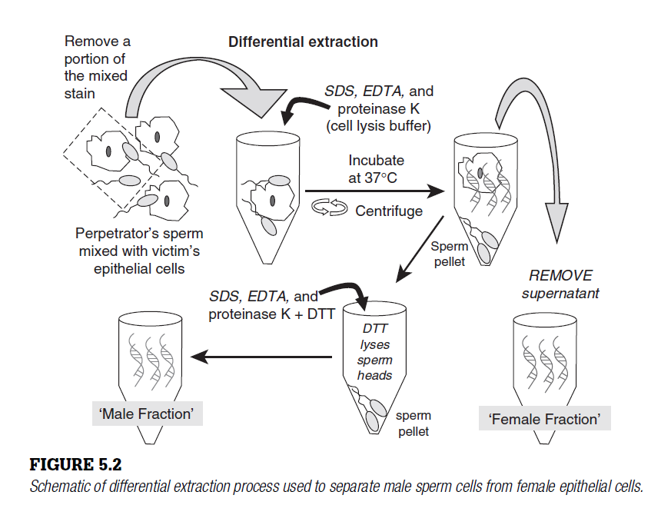PCR INHIBITORS AND DNA DEGRADATION
When extracting biological materials for the purpose of forensic DNA typing, it is important to try to avoid further degradation of the DNA template as well as to remove inhibitors of the polymerase chain reaction (PCR) where possible.
The presence of inhibitors or degraded DNA can manifest themselves by complete PCR amplifi cation failure or a reduced sensitivity of detection usually for the larger PCR products. Two PCR inhibitors commonly found in forensic cases are hemoglobin and indigo dyes from denim. Melanin found in hair samples can be a source of PCR inhibition when trying to amplify mitochondrial DNA. These inhibitors likely bind in the active site of the Taq DNA polymerase and prevent its proper functioning during PCR amplifi cation.
DNA degrades through a variety of mechanisms including both enzymatic and chemical processes. Once a cell (or organism) dies, its DNA molecules face cellular nucleases followed by bacterial, fungal, and insect onslaughts depending on the environmental conditions. In addition, hydrolytic cleavage and oxidative base damage can limit successful retrieval and amplifi cation of DNA. The main target for hydrolytic cleavage is the glycosidic base sugar bond. Breakage here leads to nucleobase loss and then a single-stranded ‘ nick ’ at the abasic site.
If a suffi cient number of DNA molecules in the biological sample break in a region where primers anneal or between the forward and reverse primers, then PCR amplifi cation effi ciency will be reduced or the target region may fail to be amplifi ed at all. Thus, heat and humidity, which speed up hydrolytic cleavage, are enemies of intact DNA molecules. Furthermore, UV irradiation (e.g., direct sunlight) can lead to crosslinking of adjacent thymine nucleotides on the DNA molecule, which will prevent passage of the polymerase during PCR.

Points for Discussion
Would there be advantages to direct sample testing without DNA extraction?
What is the purpose of DTT in an extraction procedure?
Describe some situations where differential extraction will help separate mixture components in a sexual assault case.
Why are PCR inhibitors problematic?

DNA QUANTITATION
WHY QUANTIFY DNA? When biological evidence from a crime scene is processed to isolate the DNA present, all sources of DNA are extracted and are present in the samples to be examined. Thus, nonhuman DNA, such as bacterial, fungal, plant, or animal material, may also be present in the total DNA recovered from the sample along with the relevant human DNA of interest.
To ensure that DNA recovered from an extraction is human rather than from another source such as bacteria, the FBI’s quality assurance standards (Standard 9.4) require human-specific DNA quantitation. Only after DNA in a sample has been isolated can its quantity and quality be reliably assessed.
Determination of the amount of DNA in a sample is essential for most polymerase chain reaction (PCR)-based assays because a narrow concentration range works best with multiplex short tandem repeat (STR) typing. Typically, 0.5 to 2.0 ng of input human DNA is optimal with current commercial STR kits.
Too much DNA results in overblown electropherograms that make interpretation of results more challenging and time consuming to review. Too little DNA can result in loss of alleles due to stochastic amplification and failure to equally sample the STR alleles present in the sample. Figure 6.1 illustrates the ‘Goldilocks’ principle of not wanting too much or too little DNA in a PCR reaction to produce an STR profile.
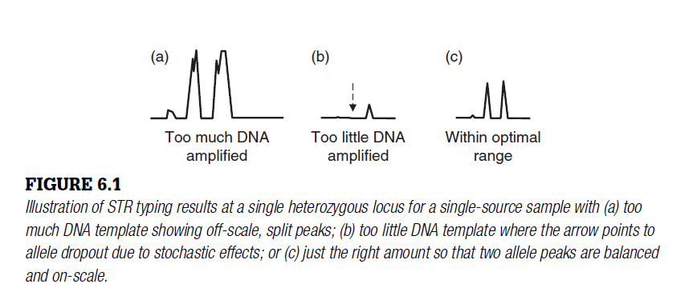
If the amount of DNA in a sample is outside of the target range for creating a ‘ just right ’ DNA profi le, then the DNA amount must be adjusted prior to putting it into the PCR reaction. The process of achieving a DNA concentration that fi ts the optimal window for analysis is called normalization . This involves diluting the sample down to the desired range or concentrating it by removing excess fluid.
Evaluation of human DNA quantity in a sample can be used to screen which samples should be sent forward through the DNA testing process. When having to wade through a large number of samples ( D.N.A. Box 6.1 ), a sample screening process, based on the amount of human DNA present, can be very helpful and cost effective. DNA quantitation that is done well can save time and preserve the often-limited DNA extracted from biological evidence.
DNA QUANTITIES USED
PCR amplifi cation is dependent on the quantity of template DNA molecules added to the reaction. Based on the amount of DNA determined to be in a sample with a quantitation method, the extracted DNA for each sample is adjusted to a level that will work optimally in the PCR amplifi cation reaction. As mentioned above, commercial STR typing kits work best with an input DNA template of around 1 ng.
A quantity of 1 ng of human genomic DNA corresponds to approximately 303 copies of each locus that will be amplifi ed ( D.N.A. Box 6.2 ). There are approximately 6 pg (one millionth of one millionth of a gram or 10 _ 12 grams) of genomic DNA in each cell containing a single diploid copy of the human genome. Thus, a range of typical DNA quantities from 0.1 to 25 ng would involve approximately 30 to 8330 copies of every nuclear DNA sequence to be examined.
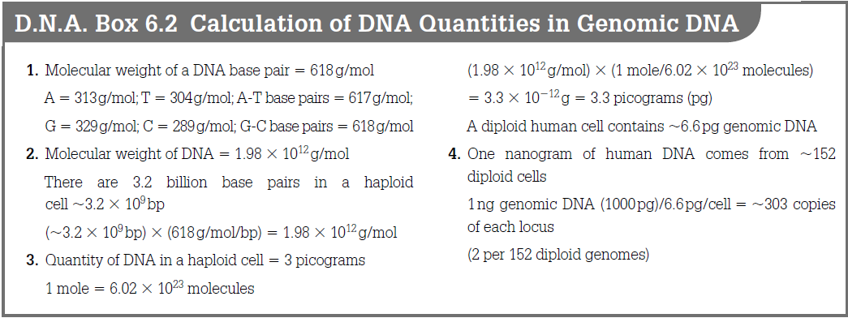
DNA QUANTITATION METHODS
A number of DNA quantitation tests have been used over the years to aid estimation of the amount of total DNA or human DNA present in a sample. These DNA quantitation tests, which will be discussed briefl y below, include UV absorbance, yield gels, slot blot, PicoGreen, AluQuant, end-point PCR, and real-time quantitative PCR. Early assays were ‘ home-brew ’ (i.e., prepared by the laboratory performing the test) while most forensic DNA quantitation is now performed using commercial kits from suppliers such as Applied Biosystems or Promega Corporation.
UV absorbance and yield gels
Early methods for DNA quantitation typically involved either measurement of absorbance at a wavelength of 260 nm or fluorescence after staining a yield gel with ethidium bromide. Unfortunately, because these approaches are not very sensitive, they consume valuable forensic specimens that are irreplaceable. In addition, absorbance measurements are not specifi c for DNA, and contaminating proteins or phenol left over from the extraction procedure can give falsely high signals. To overcome these problems, several methods have been developed for DNA quantitation purposes. These include the slot blot procedure and fl uorescence-based microtiter plate assays as well as so-called real-time or quantitative PCR approaches.
Slot blot
The most commonly used method in forensic labs during the late 1990s and beginning years of the 21st century for genomic DNA quantitation was the socalled slot blot procedure. This test was specifi c for human and other primate DNA due to a 40-bp probe that bound to a region on chromosome 17 called D17Z1. The slot blot assay was fi rst described with radioactive probes, but was later modifi ed and commercialized with chemiluminescent or colorimetric detection formats.
Slot blots involved the capture of genomic DNA on a nylon membrane followed by addition of a human-specifi c probe. Chemiluminescent or colorimetric signal intensities were then compared between a set of standards and the samples ( Figure 6.2 ).
As with almost all DNA quantitation methods, the slot blot procedure involved a relative measurement that compared unknown samples to a set of standards. These standard samples were prepared via a serial dilution from a DNA sample of known concentration. The comparison between the standards and unknowns was usually performed visually — and therefore infl uenced by the subjectivity of the analyst. However, digital capture and quantifi cation of slot blot images was also an option using a charge-coupled device (CCD) camera imaging system.
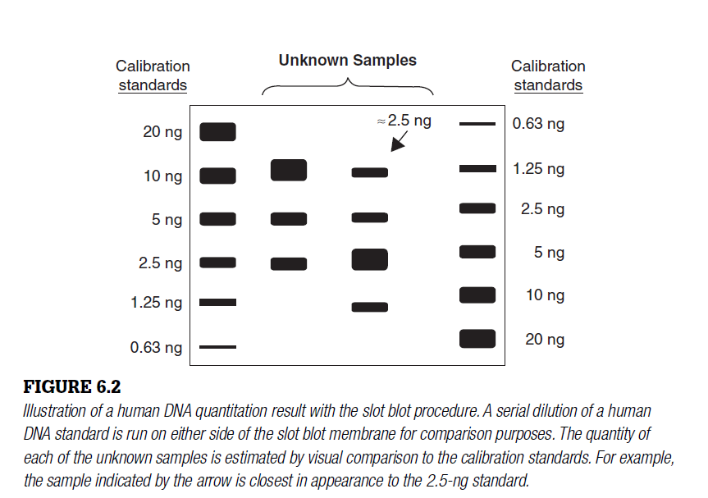
Up to 30 samples could be tested on a slot blot membrane with 6 to 8 standard samples run on each side of the membrane for comparison purposes. For example, the standards might be a serial dilution of human DNA starting with 20, 10, 5, 2.5 ng, and so forth. Typically about 5 μ L of DNA extract from each sample was consumed in order to perform this DNA quantitation test.
The slot blot assay took several hours to perform and could detect both single-stranded and double-stranded DNA down to levels of approximately 150 pg. Even when no results were seen with this hybridization assay, some forensic scientists still went forward with DNA testing and often obtained a successful STR profi le. Thus, the slot blot assay was not as sensitive as would have been preferred. In addition, as with most ‘ human-specifi c ’ tests, primate samples, such as chimpanzees and gorillas, also produced signal due to similarities in human and other primate DNA sequences. In 2006, Applied Biosystems (Foster City, CA), the fi nal commercial source for slot blot assay reagents, stopped selling the QuantiBlot Human DNA Quantitation Kit. Thus, this assay is now a thing of the past.
PicoGreen microtiter plate assay
As higher throughput methods for DNA determination are being developed, more automated procedures are needed for rapid assessment of extracted DNA quantity prior to DNA amplifi cation. To this end, in the mid-1990s, the Forensic Science Service (Birmingham, England) developed a PicoGreen assay that is capable of detecting as little as 250 pg of double-stranded DNA in a 96-well microtiter plate format. PicoGreen is a fl uorescent interchelating dye whose fluorescence is greatly enhanced when bound to double-stranded DNA.
To perform this microtiter plate assay, 5 μ L of sample are added to 195 μ L of a solution containing the PicoGreen dye. Each sample is placed into an individual well on a 96-well plate and then examined with a fl uorometer. A 96-well plate containing 80 individual samples and 16 calibration samples can be analyzed in under 30 minutes. The DNA samples are quantifi ed through comparison to a standard curve. This assay has been demonstrated to be useful for the adjustment of input DNA into the amplifi cation reaction of STR multiplexes.
It has been automated on a robotic workstation as well. Unfortunately, this assay quantifi es total DNA in a sample and is not specifi c for human DNA.
AluQuant human DNA quantitation system
Around 2000, the Promega Corporation developed a human DNA quantitation system, known as AluQuant, that enabled fairly sensitive detection of DNA using Alu repeats that are in high abundance in the human genome.
Probe-target hybridization initiated a series of enzymatic reactions that ended in oxidation of luciferin with production of light. The light intensity was then read by a luminometer with the signal being proportional to the amount of DNA present in the sample. Sample quantities were determined by comparison to a standard curve. The AluQuant assay possesses a range of 0.1 to 50 ng for human DNA and can be automated on a robotic liquid-handling workstation.
While this assay was used for several years by laboratories such as the Virginia Department of Forensic Sciences, it has been made obsolete with the introduction of real-time quantitative PCR assays.
End-point PCR
A less elegant (and less expensive than qPCR) approach for testing the ‘ amplifi ability ’ of a DNA sample is to perform an end-point PCR test. In this approach a single STR locus or other region of the human genome, such as an Alu repeat, is amplifi ed along with DNA samples of known concentrations. A standard curve can be generated from the samples with known amounts to which samples of unknown concentration are compared.
A fluorescent intercalating dye such as SYBR Green can be used to detect the generated PCR products. Based on the signal intensities resulting from amplifi cation of the single STR marker or Alu repeat region, the level of DNA can be adjusted prior to amplifying the multiplex set of DNA markers in order to obtain the optimal results. This method is a functional test because it also monitors the level of PCR inhibitors present in the sample. In the end, each of the DNA quantitation methods described here has advantages and disadvantages and could be used depending on the equipment available and the needs of the laboratory.
Real-time quantitative PCR (qPCR)
The primary purpose in performing a DNA quantifi cation test is to determine the amount of ‘ amplifi able ’ DNA. A PCR amplifi cation reaction may fail due to the presence of coextracted inhibitors, highly degraded DNA, insuffi cient DNA quantity, or a combination of all of these factors. Thus, a test that can accurately refl ect both the quality and the quantity of the DNA template present in an extracted sample is benefi cial to making decisions about how to proceed. ‘ Real-time ’ PCR assays provide such an assessment.
Instruments and assays are now available that can monitor the PCR process as it is happening, enabling ‘ real-time ’ data collection. Real-time PCR, which was fi rst described by Higuchi and coworkers at the Cetus Corporation in the early 1990s, is sometimes referred to as quantitative PCR or ‘ kinetic analysis ’ because it analyzes the cycle-to-cycle change in fluorescence signal resulting from amplifi cation of a target sequence during PCR. This analysis is performed without opening the PCR tube and therefore can be referred to as a closed-tube or homogeneous detection assay.
Several approaches to performing real-time PCR homogeneous detection assays have been published. The most common approaches utilize either the fl uorogenic 5 ‘ nuclease assay — better known as TaqMan — or use of an intercalating dye, such as SYBR Green, that is highly specifi c for double-stranded DNA molecules. The TaqMan approach monitors change in fluorescence due to displacement of a dual dye-labeled probe from a specifi c sequence within the target region while the SYBR Green assay detects formation of any PCR product.
The 5 ‘ nuclease assay (TaqMan)
TaqMan probes are labeled with two fl uorescent dyes that emit at different wavelengths (Figure 6.3). The probe sequence is intended to hybridize specifi cally in the DNA target region of interest between the two PCR primers.
Typically the probe is designed to have a slightly higher annealing temperature compared to the PCR primers so that the probe will be hybridized when extension (polymerization) of the primers begins. A minor groove binder is sometimes used near the 3 ‘ -end of TaqMan probes to enable the use of shorter sequences that still have high annealing temperatures.
The ‘ reporter ’ (R) dye is attached at the 5 ‘ end of the probe sequence while the ‘ quencher ’ (Q) dye is synthesized on the 3 ‘ end. A popular combination of dyes is FAM or VIC for the reporter dye and TAMRA for the quencher dye.
When the probe is intact and the reporter dye is in close proximity to the quencher dye, little to no fluorescence will result because of suppression of the reporter fluorescence due to an energy transfer between the two dyes.
During polymerization, strand synthesis will begin to displace any TaqMan probes that have hybridized to the target sequence. The Taq DNA polymerase used has a 5 ‘ exonuclease activity and therefore will begin to chew away at any sequences in its path (i.e., those probes that have annealed to the target sequence). When the reporter dye molecule is released from the probe and is no longer in close proximity to the quencher dye, it can begin to fl uoresce ( Figure 6.3 ). An increase in the fl uorescent signal results if the target sequence is complementary to the TaqMan probe.
Some assays, such as the Quantifi ler kit, include an internal PCR control (IPC) that enables verifi cation that the polymerase, the assay, and the detection instrumentation are working correctly. In this case, the IPC is labeled with a VIC (green) reporter dye and hybridizes to a synthetic template added to each reaction. The TaqMan probe for detecting the target region of interest is labeled with a FAM (blue) reporter dye and therefore is spectrally resolvable from the green VIC dye. Instruments such as the ABI Prism 7000 or 7500 Real Time PCR System ( Figure 6.4 ) enable another dye like ROX (red dye) to be placed in each well to adjust for well-to-well differences across a plate through background subtraction.
Real-time PCR analysis
Three distinct phases defi ne the PCR process: geometric or exponential amplifi cation, linear amplifi cation, and the plateau region. These regions can be seen in a plot of fluorescence versus PCR cycle number ( Figure 6.5 ). During exponential amplifi cation, there is a high degree of precision surrounding the production of new PCR products. When the reaction is performing at close to 100% effi ciency, then a doubling of amplicons occurs with each cycle. A plot of cycle number versus a log scale of the DNA concentration should result in a linear relationship during the exponential phase of PCR amplifi cation.
A linear phase of amplifi cation follows the exponential phase as one or more components fall below a critical concentration and amplifi cation effi ciency slows down to an arithmetic increase rather than the geometric one in the exponential phase. Since components such as deoxynucleotide triphosphates (dNTPs) or primers may be used up at slightly different rates between reactions, the linear phase is not as precise from sample to sample and therefore is not as useful for comparison purposes.
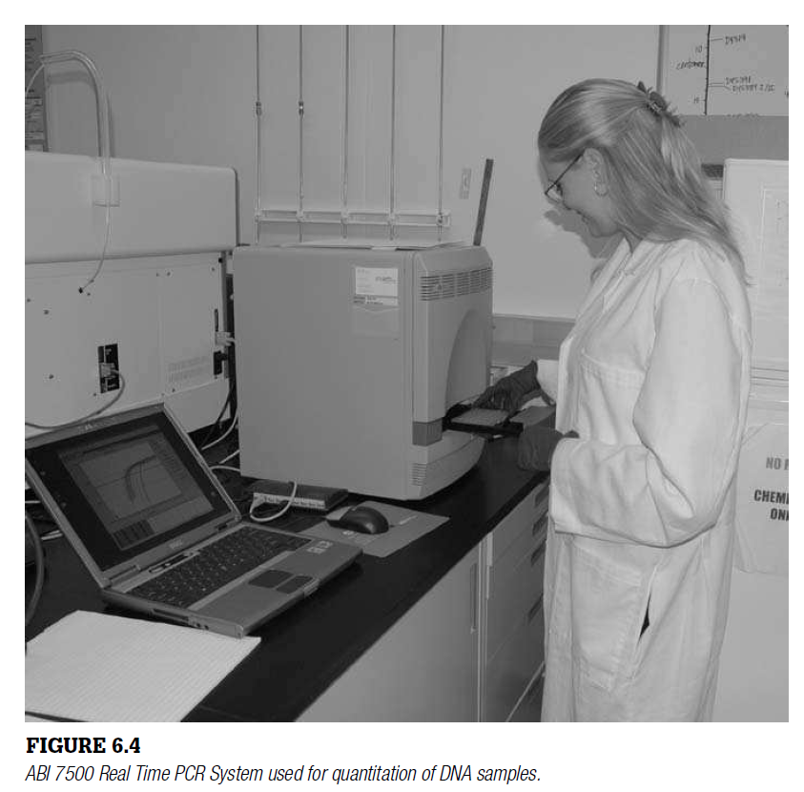
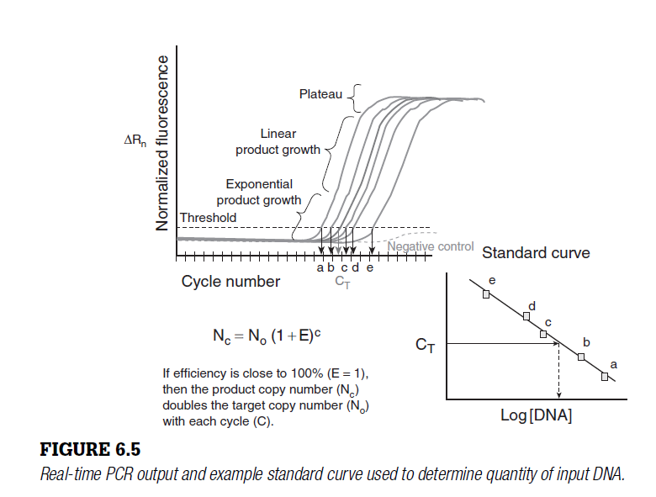
The final phase of PCR is the plateau region where accumulation of PCR product slows to a halt as multiple components have reached the end of their effectiveness in the assay. The fl uorescent signal observed in the plateau phase levels out. The accumulation of PCR product generally ceases when its concentration reaches approximately 10 _ 7 mol/L.
The optimal place to measure fluorescence versus cycle number is in the exponential phase of PCR where the relationship between the amount of product and input DNA is more likely to be consistent. Real-time PCR instruments use what is termed the cycle threshold (C T) for calculations. The C T value is the point in terms of PCR amplifi cation cycles when the level of fluorescence exceeds some arbitrary threshold, such as 0.2, that is set by the real-time PCR software to be above the baseline noise observed in the early stages of PCR. The fewer cycles it takes to get to a detectable level of fluorescence (i.e., to cross the threshold set by the software), the greater the initial number of DNA molecules put into the PCR reaction. Thus a plot of the log of DNA concentrations versus the C T value for each sample results in a linear relationship with a negative slope ( Figure 6.5 ).
The cleavage of TaqMan probes or binding of SYBR Green intercalating dye to double-stranded DNA molecules results in an increase in fluorescence signal. This rise in fl uorescence can be correlated to the initial DNA template amounts when compared with samples of known DNA concentration. For example, in Figure 6.5 , fi ve samples (a, b, c, d, e) are used to generate a standard curve based on their measured C T values. Provided that there is good sample-to-sample consistency and precision, a sample with an unknown DNA quantity can be compared to this standard curve to calculate its initial DNA template concentration.
Several real-time PCR assays have been developed with the human identity testing market in mind. Commercial kits for detecting human DNA as well as a real-time PCR assay for determining the amount of human Y-chromosome DNA present in a sample are now available. These kits include Quantifi ler, Quantifi ler Y, and Quantifi ler Duo from Applied Biosystems and Plexor HY from Promega Corporation.
COMPARISON OF METHODS
Several interlaboratory tests to evaluate DNA quantifi cation methods have been conducted by the U.S. National Institute of Standards and Technology (NIST) to better understand the measurement variability seen with various techniques. A 10-fold range of reported concentrations was observed in one study. Most DNA quantitation measurements are precise to within a factor of two if performed properly. While this degree of imprecision may seem excessive, quantitation results are usually suffi ciently valid to estimate DNA template amounts that will enable optimal PCR amplifi cation.
Points for Discussion
What is the optimal quantity of DNA for most commercial STR kits?
What is the effect of too much or too little DNA being amplifi ed?
What problems might exist with having quantitation assays that are less sensitive than downstream DNA testing methods?
Why is qPCR a preferred technique over slot blot methods?
How can reliable DNA quantitation aid decisions in terms of what route to take?
